ANNUAL DEGREE PROGRAM ASSESSMENT REPORT

Overview
The emphasis of the report should be on PLO and CASLO assessment, action items emerging from those assessments, and a table listing the top three budget requests from each degree program. Bullet points are certainly acceptable for the sections requiring written responses. Finally, if you respond to the system data please keep each section (demand, effectiveness and efficiency) to 100 words or fewer. Refer to the ARPD Instructions when you upload your report elements to the system website. The roman numerals indicate the corresponding system item number for when you upload your report to the UH System website.
http://www.hawaii.edu/offices/cc/arpd/instructional.php?year=2015&action=quantitativeindicators&college=HAW
Select Maui College and your program in the drop down menus.
On the page that shows the Quantitative indicators, click on “web submission”. You will log in to get to your program submission pages.

Remember to click on “save” icon for EACH SECTION.

See the end of this document for more assistance with web submission.

2016-17 Program Review preparation guidelines
Program Name: Construction Technology (CTEC)
DESCRIPTION TAB
- Program Description:
The Construction Technology program prepares students in general building construction and maintenance of large or small structures. The program allows students to explore different trades prior to selecting a specialization.

- Briefly respond for each cautionary and/or unhealthy Quantitative Indicator (II):
Demand Indicator: Cautionary-
According to the National Association of Homebuilders (NAHB), we are about to encounter the largest amount of unfilled construction related replacement positions ever with the retirement of tens of thousands of baby boomer generation tradespersons each year and a limited amount of interested replacement prospects over the next several years representing a shrinking workforce, ensuring vast employment opportunities for CTEC students to apply the skills and knowledge recognized in the attainment of their CTEC certificates and degrees.
As noted in the CTEC Program Description, “The Construction Technology program prepares students in general building construction and maintenance of large or small structures. The program allows students to explore different trades prior to selecting a specialization”. This means that CTEC program students compete for jobs at entry or intermediate levels in many trade fields outside of the confinement of programs to one Classification of Instructional Programs (CIP) Code, in the case of UHMC’s CTEC program, 46.0000 Construction Trades, General. However, the program’s curriculum introduces and familiarizes students with industry knowledge and skills at a level that affords students the opportunity for gainful employment under many CIP Codes:
- 46.0000) Construction Trades, General.
- 46.01) Mason/Masonry.
- 46.0101) Mason/Masonry.
- 46.02) Carpenters.
- 46.0201) Carpentry/Carpenter.
- 46.03) Electrical and Power Transmission Installers.
- 46.0301) Electrical and Power Transmission Installation/Installer, General.
- 46.0302) Electrician.
- 46.0303) Lineworker.
- 46.0399) Electrical and Power Transmission Installers, Other.
- 46.04) Building/Construction Finishing, Management, and Inspection.
- 46.0401) Building/Property Maintenance.
- 46.0402) Concrete Finishing/Concrete Finisher.
- 46.0403) Building/Home/Construction Inspection/Inspector.
- 46.0404) Drywall Installation/Drywaller.
- 46.0406) Glazier.
- 46.0408) Painting/Painter and Wall Coverer.
- 46.0410) Roofer.
- 46.0411) Metal Building Assembly/Assembler.
- 46.0412) Building/Construction Site Management/Manager.
- 46.0413) Carpet, Floor, and Tile Worker.
- 46.0414) Insulator.
- 46.0415) Building Construction Technology.
- 46.0499) Building/Construction Finishing, Management, and Inspection, Other.
- 46.05) Plumbing and Related Water Supply Services.
- 46.0502) Pipefitting/Pipefitter and Sprinkler Fitter.
- 46.0503) Plumbing Technology/Plumber.
- 46.0504) Well Drilling/Driller.
- 46.0505) Blasting/Blaster.
- 46.0599) Plumbing and Related Water Supply Services, Other.
- 46.99) Construction Trades, Other.
- 46.9999) Construction Trades, Other.
- 47.0106) Appliance Installation and Repair Technology/Technician
- 47.02) Heating, Air Conditioning, Ventilation and Refrigeration Maintenance Technology/Technician (HAC, HACR, HVAC, HVACR).
- 47.0201) Heating, Air Conditioning, Ventilation and Refrigeration Maintenance Technology/Technician.
- 15.0501) Heating, Ventilation, Air Conditioning and Refrigeration Engineering Technology/Technician.
- 15.0503) Energy Management and Systems Technology/Technician.
- 15.0505) Solar Energy Technology/Technician.
- 15.0506) Water Quality and Wastewater Treatment Management and Recycling Technology/Technician.
- 15.1301) Drafting and Design Technology/Technician, General.
- 15.1302) CAD/CADD Drafting and/or Design Technology/Technician.
- 15.1303) Architectural Drafting and Architectural CAD/CADD.
https://nces.ed.gov/ipeds/cipcode/browse.aspx?y=55
CTEC graduates regularly seek and are successful in gaining employment in these various trades and facilities operations and maintenance career paths throughout the state of Hawaii, the mainland, and other geographic regions and traditionally do not limit themselves to accepting only the new and replacement positions (County Prorated) used to calculate the Demand Health Call. Additionally, many of the CTEC program's students are incumbent workers seeking to gain promotion with their current employers through the aquisition of Certificates of Competance (COs) offered in the CTEC Program Map.
Demand Indicators |  | Program Year
 |  | 14-15 | 15-16 | 16-17
1 | New & Replacement Positions (State) | 90 | 74 | 50
2 | *New & Replacement Positions (County Prorated) | 9 | 1 | 4
3 | Number of Majors | 73 | 62 | 62

Although the CTEC program’s Demand Health Call has scored an “Unhealthy” rating since 2008, and shows improvement with the 2016-2017 "Cautionary" score, program graduates continue to thrive in gaining industry employment as a result of their degrees and certificates awarded through the UHMC CTEC Program, indicating that the demand indicators data and/or formulas do not reflect the true health of the program.
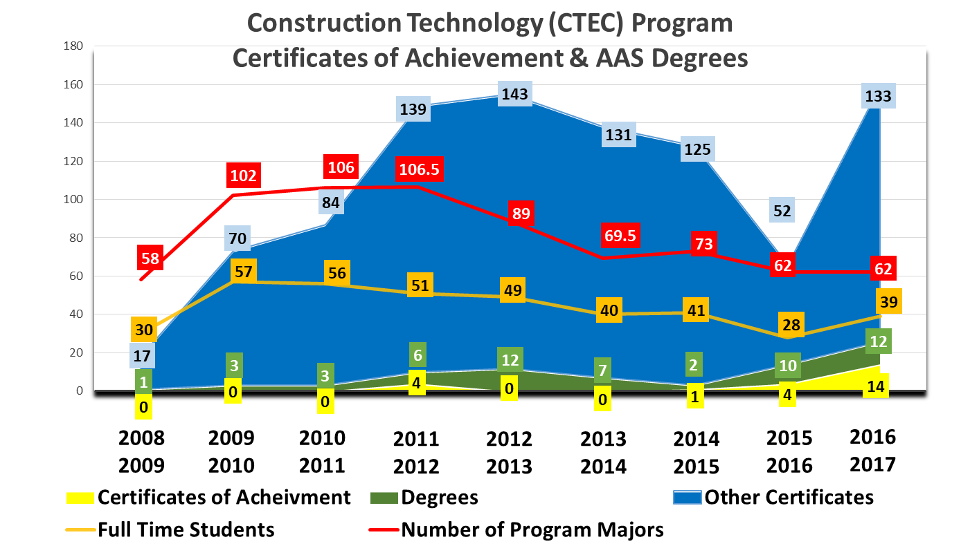
The “County Prorated New and Replacement Positions” indicate only 4 positions available for CTEC graduates, while observation of local Maui newspaper and Craigslist ads from August 22, 2017 to September 22, 2017 reveal more than 85 job posts for entry to intermediate level positions CTEC students are seeking in various fields of construction and building maintenance trades. Also, the Maui local Carpenters Union added more than 20 new or replacement positions in the fall of 2017, employing a number of recent CTEC graduates.
Efficiency Indicator: Cautionary-
- Efficiency: Fill Rate 87.4%= Healthy
- Student/Faculty Ratio 62:1= Unhealthy
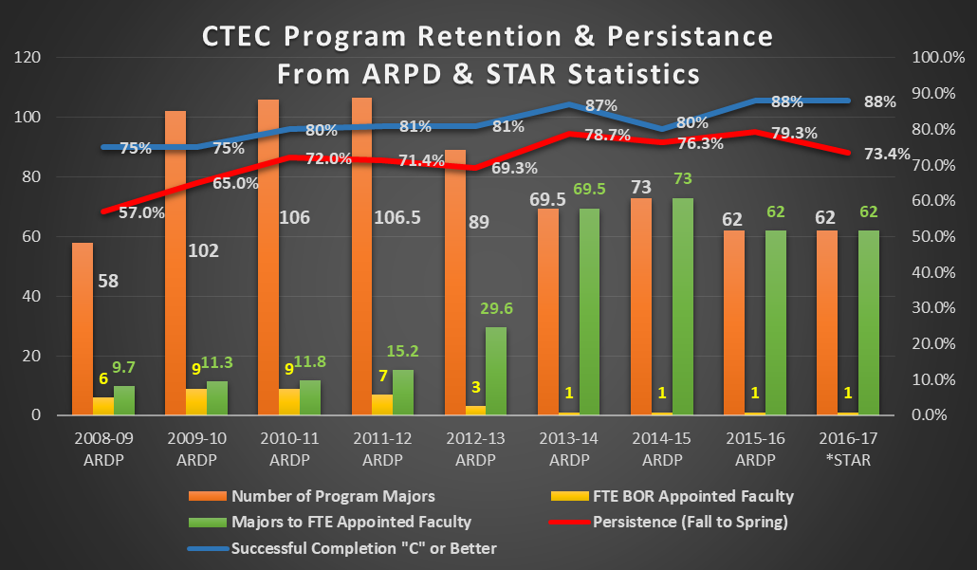
Efficiency Indicators |  | Program Year
 |  | 14-15 | 15-16 | 16-17
9 | Average Class Size | 17.4 | 13.7 | 16.3
10 | *Fill Rate | 95.8% | 74.4% | 87.4%
11 | FTE BOR Appointed Faculty | 1 | 1 | 1
12 | *Majors to FTE BOR Appointed Faculty | 73 | 62 | 62
13 | Majors to Analytic FTE Faculty | 27.4 | 26.2 | 29.9
13a | Analytic FTE Faculty | 2.7 | 2.4 | 2.1

From 2008-2013, the program was supported with 3-9 faculty positions, always meeting or exceeding the “Healthy” rating for student to faculty ratio in the scoring rubric. Due to changes in program full-time faculty and administrative budget decisions in Fall 2013 the CTEC program was left with one FT Faculty position representing more than 60 students each academic year.
Prior to preparing their report for final UHMC’s final accreditation, The WSCUC Senior Accreditation Team conducted interviews with program coordinators with particular focus on larger single-faculty programs and how various challenges were being met and supported. Throughout the accreditation process, the WSCUC Team has continually made recommendations to UHMC, based on faculty-to-student ratios that facilitate program and student success, for faculty count increases for single-faculty programs with disproportionate student to faculty ratios as evidenced in ARPD data, CTEC Program Reviews and Advisory Committee recommendations, and consistently in program and department budget requests from 2013 to present.
The workload of one FT Faculty and the current Program Lecture staff does not support scheduling of classes, or expansion of the programs curriculum to meet industry educational requirements for specific trades, or for students to graduate within 2, or more often, 3 years. As trades course lecturers are traditionally current experts in their specific trade, the majority teach around their “day job” schedules and due to guidelines for class sizes for most CTE/VocTech hands-on lab courses, and with approximately 60-65% part-time student enrollment, students often must postpone graduation for multiple semesters which complicates retention, persistence, and completion issues.
3b | Fall Full-Time | 40% | 34% | 33%
3c | Fall Part-Time | 60% | 66% | 67%
3d | Fall Part-Time who are Full-Time in System | 0% | 0% | 0%
3e | Spring Full-Time | 40% | 27% | 42%
3f | Spring Part-Time | 60% | 73% | 58%
3g | Spring Part-Time who are Full-Time in System | 0% | 0% | 1%
17 | Successful Completion (Equivalent C or Higher) | 80% | 88% | 88%
18 | Withdrawals (Grade = W) | 27 | 6 | 17
19 | *Persistence Fall to Spring | 76.3% | 79.3% | 73.6%
19a | Persistence Fall to Fall | 51.4% | 58.1% | 37.7%
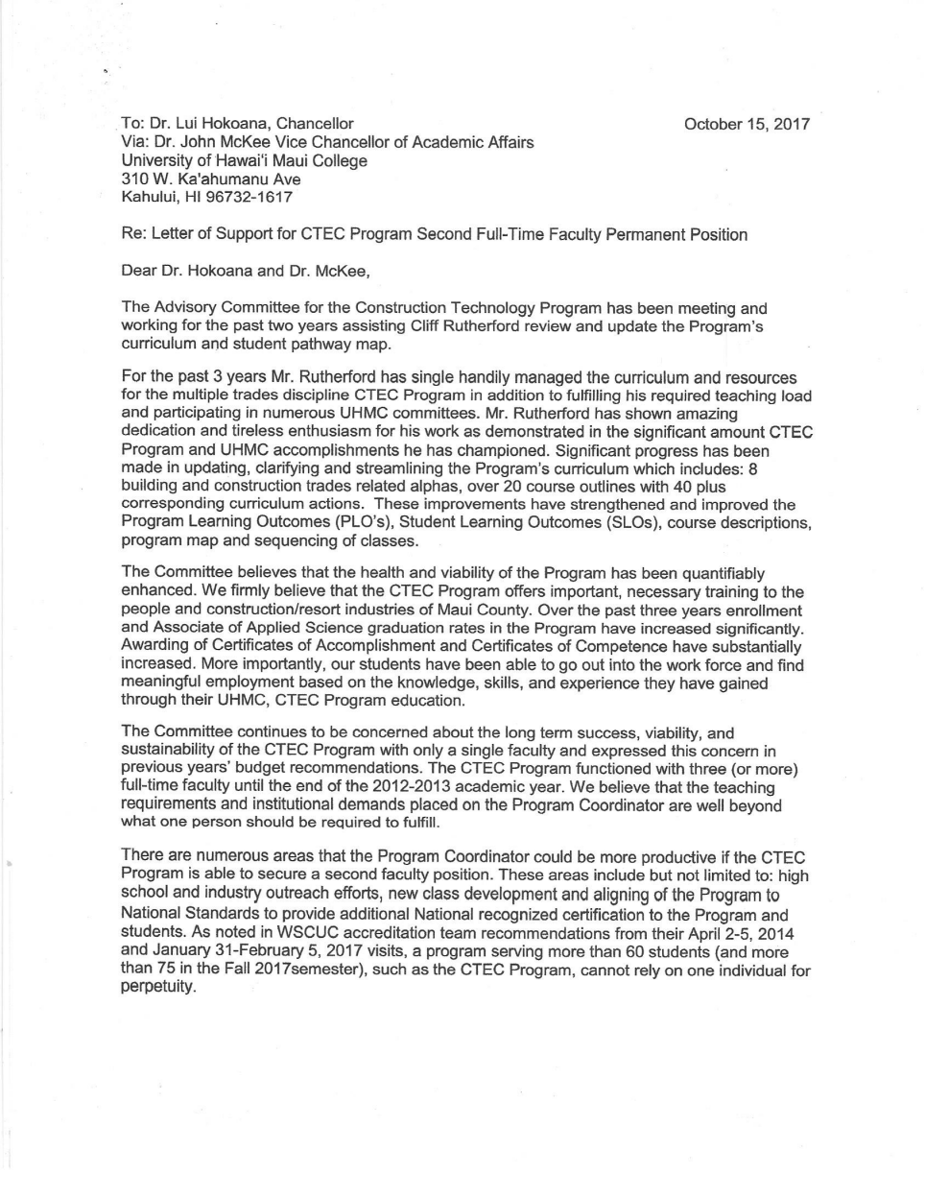
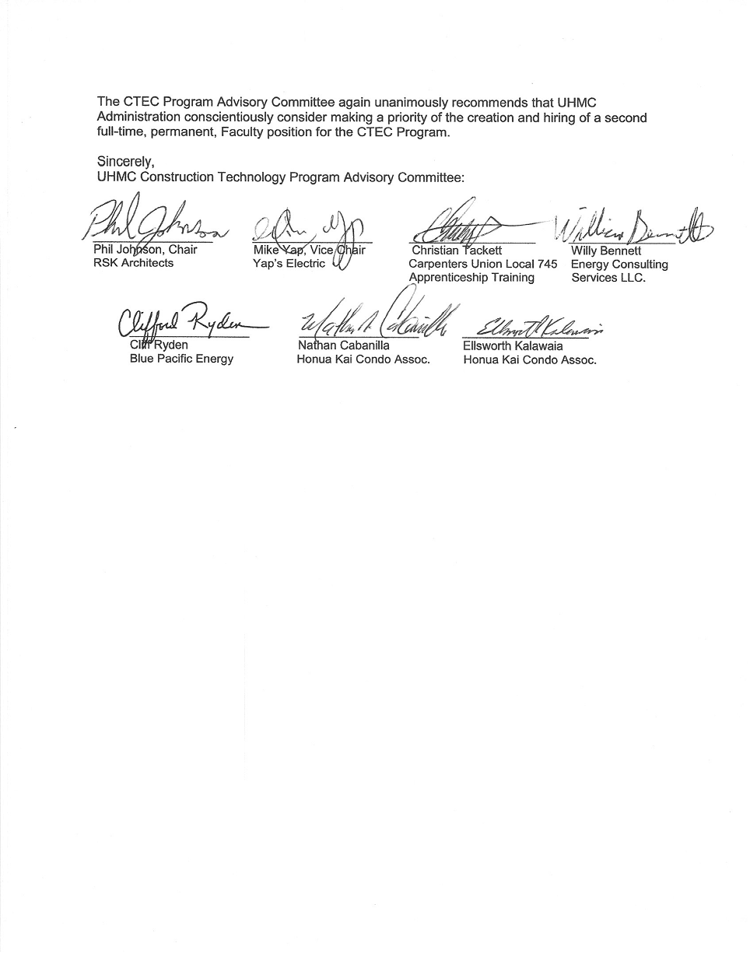Effectiveness Indicator: Healthy

Funding for a second CTEC FT Faculty position will continue to be the primary budget request for the CTEC program. The position will support student learning and offer students more sections of classes more often allowing for enrollment growth, address issues such as program recruitment and unmet Perkins indicators 5P1 and 5P2 (in relation to support of nontraditional students). Additionally, the position will expedite curriculum development and industry certification of students, and program representation within the college and community, ultimately elevating and reinforcing our graduates' employment potential in the building and construction industry.
Funding for a second FT Faculty position supports the following strategic directions:
Quality of Learning
- Objective 1: A college culture that promotes excellence in teaching and learning for students, faculty and staff.
- Objective 2: High quality degrees, certificates and courses that meet student, industry, and relevant stakeholder need.
- Objective 3: Physical and fiscal support for high-quality teaching and learning.
- Objective 4: Broad support for non-traditional and underprepared students with varied challenges.
Student Success
- Objective 1: College adopts policies and practices to help students enroll in and progress through college.
- Objective 2: College provides optimal learning environments and effective and timely support for struggling students (especially Native Hawaiian and underrepresented students).
Community Needs & Workforce Development
Goal: To prepare students to meet current and emerging community and workforce needs and opportunities.
- Objective 1: Continuous evidence-based understanding of community and workforce needs and opportunities.
- Objective 2: Credit and non-credit curriculum that are connected with relevant community and economic needs.
- Objective 3: High quality Outreach centers to meet the credit and non-credit needs of the community
- Objective 4: Consistent communication with the community about the College’s mission and offerings
Resource Implications
FTE C-2 Instructor Position, 9 month, tenure track- Base Salary: $54,084 (2017-2021 UHPA/BOR Contract)
ANALYSIS TAB
- Analysis of the Program-
See responses to quantitative indicators under “Description Tab”
- Briefly discuss any new significant program actions (new certificates, stopout, gain or loss of positions) as results of last year’s action plan.
No changes reported.
- If relevant, share a brief analysis for any Perkins Core Indicator not met.
Funding for a second CTEC FT Faculty position will continue to be the primary budget request for the CTEC program. The position will support student learning and offer students more sections of classes more often allowing for enrollment growth, address issues such as program recruitment and unmet Perkins indicators 5P1 and 5P2 (in relation to support of nontraditional students).
- Goals and/or actions from previous assessment results
- Describe results from previous assessment goal and/or action implementation

  - PLO
All SUSC PLOs were assessed in Fall 2015. During PLO assessment the SUSC Program Advisory Committee recommended establishing new PLOs representative of current and changing industry trends and workforce expectations. The Advisory Committee also found that the program name “Sustainable Construction Technology” did not appropriately represent the true mission of the program and recommended that the program name be changed to “Construction Technology (CTEC)”. Both actions were submitted and approved to begin In Fall 2016.

  - CASLO
Purchased industry standard instructional solar thermal diagnostic center equipment through and AC/DC electrical lab through campus equipment replacement funds to address previous critical thinking CASLO assessment findings. Provides assessment of critical thinking as applied to student design and troubleshooting skills of English as second language students and kinesthetic learners after Instructor demonstration of textbook theories and practices. New equipment will be implemented into various course lesson plans for ENRG, ELEC, and MAIN courses in Spring 2018.
P-SLOs TAB
- PLO selected for assessment (click on the PLO assessed – it will turn green).
For the 2016-2017 program year, some or all of the following P-SLOs were reviewed by the program:
Assessed  this year? |  | Program Student Learning Outcomes
1 | Yes | Use and maintain appropriate materials, tools, equipment, and procedures to carry out tasks performed on construction projects according to safety and industry standards.
2 | Yes | Use math, computer, and oral and written communication skills to solve construction project problems.
3 | Yes | Create and maintain accurate documentation of construction and maintenance projects.
4 | Yes | Describe industry standard Green Building practices in construction and maintenance projects.
5 | Yes | Read and interpret blueprints, and/or schematics, and specifications to plan projects.
6 | Yes | Demonstrate the craftsmanship standards of dependability, punctuality, and quality.
7 | Yes | Examine and use proper mechanical, electrical, and carpentry codes and standards applicable to construction and repair.

- Industry Validation (check all that apply):

Advisory Committee Meeting(s) _X_, How many? _3_
Did Advisory Committee discuss CASLO/PLO? Yes_X_ No__
Coop Ed Placements _X_ Fund raising activities/events __ Service Learning __
Provide program services that support campus and/or community
Outreach to public schools _X_
Partner with other colleges, states and/or countries _X_
Partner with businesses and organizations _X_
Other_X_ Describe_PLO/CASLO Assessment Ad hoc Committees, Articulation agreements with Job Corps Maui and UHMC OCET Certificate of Professional Development (CPD) _______

- Expected level of Achievement:
For the PLO assessed, _100_ % of students completing the assignment/course expected to meet expectations for the assignment/course.
- Courses (or assignments) Assessed:
CASLOs:
• COM 145 Interpersonal Communication I
All PLOs:

• AEC 80
• BLPR 22
• CARP 20
• CARP 41
• CARP 42
• CARP 43
• ENRG 101
• ENRG 103
• OSH 20

- Assessment strategy/Instrument/Evidence (check all that apply):
CASLO Assessment
COM 145:
Work Sample__ Portfolio__ Project _X_ Exam __ Writing Sample __
Other_X_ Please explain: Slideshow/Oral Presentation

PLO Assessment:
In the Fall 2014 semester, a new program advisory committee consisted of local industry experts in each of the program’s alpha fields of study was recruited by the CTEC program coordinator to provide expertise in evaluating curriculum and student learning relative to industry requirements. Their recommendations from Fall 2014- Spring 2017 have required extensive reorganization and streamlining of the program’s curriculum over the last three years, and significant program changes to include the change of the program name to “Construction Technology” and developing new PLOs, which became effective in the Fall 2016 semester, to better represent the industries the CTEC program serves.
Course outlines submitted as new, 5-Year review, or modification from Fall 2016 through Fall 2017 have, and are being evaluated by ad hoc committees consisting of program faculty, lecturers, and industry experts from the CTEC Advisory Committee during the 5-Year course review process in order establish which, and how, specific courses in the program map provide evidence of learning meeting the program’s PLOs and to reflect this in the mapping of course SLOs to the program’s new PLOs.
As when the CTEC program’s new PLOs were implemented into curriculum submissions for ELEC, MAIN, and WELD in 2015-2016 and evaluated at that time, those being prepared for the Fall 2017 semester, AEC, BLPR, CARP, ENRG, and OSH courses were assessed by the CTEC Program Advisory Committee ad hoc members during the 2016-2017 academic year to map SLOs with PLOs in the submissions. The findings of the evaluators are reflected in Section E, “Results of Program Assessment”, and in the PLO chart found in Section G, “Next Steps”.
In order to provide adequate confirmation of which of and how the program’s seven new PLOs are expected to be met in each course, which a single assessment piece does not provide, multiple avenues of inquiry were provided to the ad hoc PLO Assessment Committees.
Evidence for the assessment of the program’s seven new PLOs relative to each course evaluated in the 2016-2017 academic year include the following:
- Student course evaluations- All courses in AEC, BLPR, CARP, ENRG, and OSH alphas
- Student exit interviews- ENRG 101, ENRG 103
- Classroom and/or lab observation of in session classes- ENRG 101, OSH 20, CARP 20, and CARP 41
- PCC articulation agreements, recommendations and discussions- All courses in AEC, BLPR, and CARP alphas
- Course outline and syllabus submissions- All courses in AEC, BLPR, CARP, ENRG, and OSH alphas
- Discussion of lesson plans, sample grading rubrics and achievement of SLOs with course instructors- All courses in AEC, BLPR, CARP, ENRG, and OSH alphas
- Student presentation or project samples- All courses in AEC, BLPR, CARP, ENRG, and alphas

- Results of program assessment:
PLO Assessment Findings:
- AEC 80- Present: Patricia Inman, Instructor; Phil Johnson, CTEC Advisory Committee Chair/Industry Expert, Reiki Kono & Sunnerland (Architect/Project Manager); Clifford Rutherford, CTEC Program Coordinator
  - During the PLO assessment, the Advisory Committee found that the curriculum for AEC 80 consisted of redundant coursework and SLOs achieved in the prerequisite BLPR 22 course.
  - After evaluating current UH AEC courses that would provide SLOs that were better suited for meeting CTEC program PLOs and program level attainment of industry required skills, the committee recommended that the AEC 80 course be replaced by AEC 110. Course outline for AEC 110 to be submitted Fall 2017.
  - The assessment committee found substantial evidence of learning in the proposed coursework, instruction methods, and evidence presented to support that CTEC program PLOs 1, 2, 3, 5, and 6 are expected to be met by students completing the new AEC 110 course.
- BLPR 22- Present: Carlton Atay, Instructor; Phil Johnson, CTEC Advisory Committee Chair/Industry Expert, Reiki Kono & Sunnerland Architects; Chris Tackett, Carpenters Apprenticeship Training, Industry Expert; Clifford Rutherford, CTEC Program Coordinator
  - Change number due to articulation of subject code, number, title, credits, method, and TEs as agreed upon at CARP Program Coordinators Council (PCC) 9/16/2016.
  - Submitted as 100 level course under advisement of Construction Technology Program Advisory Committee.
  - Course will be replaced by new course BLPR 101, course outline to be submitted Fall 2017
  - The assessment committee found substantial evidence of learning in the proposed coursework, instruction methods, and evidence presented to support that CTEC all seven program PLOs are expected to be met by students completing the new BLPR 101 course.

- CARP 20- Present: Carlton Atay, Instructor; Phil Johnson, CTEC Advisory Committee Chair; Chris Tackett, Carpenters Apprenticeship Training, Industry Expert; Clifford Rutherford, CTEC Program Coordinator
  - The assessment committee found substantial evidence of learning in the assigned coursework, instruction methods, and evidence presented to support that PLOs 1, 2, 5, 6, and 7 are expected to be met by students completing the CARP 20 course.
  - PCC Articulated FA 15
  - 5-Year review course outline to be submitted Fall 2017
- CARP 41- Present: Carlton Atay, Instructor; Phil Johnson, CTEC Advisory Committee Chair; Chris Tackett, Carpenters Apprenticeship Training, Industry Expert; Clifford Rutherford, CTEC Program Coordinator
  - UHMC change of course number to CARP 40 and name due to PCC agreement of Fall 2016.
  - Course outline for CARP 40 to be submitted Fall 2017
  - The assessment committee found substantial evidence of learning in the proposed coursework, instruction methods, and evidence presented to support that PLOs 1, 2, 4, 5, 6, and 7 are expected to be met by students completing the new CARP 40 course.
- CARP 42- Present: Carlton Atay, Instructor; Phil Johnson, CTEC Advisory Committee Chair; Chris Tackett, Carpenters Apprenticeship Training, Industry Expert; Clifford Rutherford, CTEC Program Coordinator
  - PCC Articulated FA 16. Not taught at UHMC in 5+ years. Course to be deleted in Fall 2017
- CARP 43- Present: Carlton Atay, Instructor; Phil Johnson, CTEC Advisory Committee Chair; Chris Tackett, Industry Expert, Carpenters Apprenticeship Training; Clifford Rutherford, CTEC Program Coordinator
  - PCC Articulated FA 16, Course outline to be submitted Fall 2017
  - The assessment committee found substantial evidence of learning in the assigned coursework, instruction methods, and evidence presented to support that all seven of the CTEC program PLOs are expected to be met by students completing the CARP 43 course.

- ENRG 101- Present: Clifford Rutherford, Instructor, CTEC Program Coordinator; Phil Johnson, CTEC Advisory Committee Chair; Cliff Ryden, Blue Pacific Energy LLC., Industry Expert;
  - The assessment committee found substantial evidence of learning in the assigned coursework, instruction methods, and evidence presented to support that CTEC program PLOs 2, 4, 5, and 7 are expected to be met by students completing the ENRG 101 course.
  - 5-Year Review to be submitted Fall 2017
- ENRG 103- Present: Alex Deroode, Instructor; Phil Johnson, CTEC Advisory Committee Chair; Industry Expert, Willy Bennett, Energy Consulting Associates LLC.; Clifford Rutherford, CTEC Program Coordinator
  - The assessment committee found substantial evidence of learning in the assigned coursework, instruction methods, and evidence presented to support that all seven CTEC program PLOs are expected to be met by students completing the ENRG 103 course.
  - 5-Year Review to be submitted Fall 2017
OSH 10- Present: Leomer Domingo, Instructor/OSHA Industry Expert; Phil Johnson, CTEC Advisory Committee Chair; Mike Yap, CTEC Advisory Committee Vice Chair/ Industry Expert, Yap Electric; Clifford Rutherford, CTEC Program Coordinator
- PLO assessment of this course noted that the curriculum being used was for "general industry" and was being used as a requirement for the Construction Technology (CTEC) Program which requires a different student learning outcomes and competencies. Although it is noted that this course is not a requirement for any other program at UHMC, it is also noted that students from multiple programs still take this course. OSH 20 will still continue to address the needs of general industry students. A new course, OSH 10: Occupational Safety & Health for Construction Trades, will be proposed in Fall 2017 to accommodate the industry requirements of the CTEC Program. Students will receive OSHA 10 Hour Training for Construction Industry card upon completion of the OSH 10 course with grade of C or better.

The assessment committee found substantial evidence of learning in the industry standardized coursework, instruction methods, and evidence presented to support that CTEC program PLOs 1, 5, 6, and 7 are expected to be met by students completing the new OSH 10 course.

- Other comments:
Describe CASLO assessment findings and resulting action plans. Go to Laulima UHMC CASLO Assessment for your program’s “Assessment results” and summarize below.

CASLO Assessment Committee members: Eric Engh, Samantha Bowe, and Celeste Baldwin; Oral Communications Focus Instructor, Ron St. John; CTEC Program Advisory Committee Chair, Phil Johnson; and CTEC Program Coordinator, Clifford Rutherford

CASLO assessment findings | Action plan to address findings
Although the course title and description for COM 145 focuses on interpersonal communications in one-to-one settings, this particular assignments focus seemed to be to ward communicating with larger audiences. However, the assignment did explore a few aspects of the communication skills and competencies (eye contact, organization, self-confidence, and the ability to collaborate in group settings) required for Construction Technology Program graduates. CASLO Committee recommended that COM 130 Business Communications-Oral would be better suited for program graduates. | Curriculum submissions for Fall 2017 will include changing program requirements of Oral Communication from COM 145 to COM 130 in the CTEC program map.

- Next steps:
For program learning outcomes (check all that apply):
Assess the next PLO_X__ Review PLOs___ Adjust assignment used for PLO___
Adjust course used for PLO___ Meet with Advisory Committee__X__
Other__X_ Please explain:

Future PLO assessment will follow the mapped assessment schedule. Course evidence should be selected to evaluate at least two marked PLOs for the course/s in the scheduled semester and year.
PLO MAP by COURSE | AEC 110 | BLPR 101 | CARP 20 | CARP 40 | CARP 43 | ELEC 20 | ELEC 23 | ENRG 101 | ENRG 103 | MAIN 20 | MAIN 30 | MAIN 40 | MAIN 50 | MAIN 55 | MAIN 60 | MAIN 65 | MAIN 70 | OSH 10 | WELD 19D
PLO 1 | X | X | X | X | X | X | X |  | X | X | X | X | X | X | X | X | X | X | X
PLO 2 | X | X | X | X | X | X | X | X | X | X | X | X | X | X | X | X | X | X
PLO 3 | X | X |  |  | X | X | X |  | X | X | X | X | X | X | X | X | X | X
PLO 4 |  | X |  | X | X | X | X | X | X | X | X | X | X | X | X | X | X
PLO 5 | X | X | X | X | X | X | X | X | X | X | X | X | X | X | X | X | X | X | X
PLO 6 | X | X | X | X | X | X | X |  | X | X | X | X | X | X | X | X | X |  | X
PLO 7 |  | X | X | X | X | X | X | X | X | X | X | X | X | X | X | X | X | X | X
Last PLO Assessment | SP 2017 | SP 2017 | SP 2017 | SP 2017 | SP 2017 | SP 2015 | SP 2015 | SP 2017 | SP 2017 | FA 2016 | FA 2016 | FA 2016 | FA 2016 | FA 2016 | FA 2016 | FA 2016 | FA 2016 | SP 2017 | SP 2015
Next PLO Assessment | FA 2020 | SP 2021 | FA 2021 | FA 2021 | SP 2022 | SP 2018 | SP 2018 | FA 2022 | FA 2022 | FA 2018 | FA 2018 | SP 2019 | SP 2019 | FA 2019 | FA 2019 | SP 2020 | SP 2020 | FA 2020 | FA 2017
Course 5-Year Review Submission Schedule | 2021 | 2021 | 2021 | 2021 | 2021 | 2018 | 2018 | 2022 | 2022 | 2019 | 2019 | 2019 | 2019 | 2019 | 2020 | 2020 | 2020 | 2022 | 2018

- Please list any professional development needs you may have for your program.
Industry recognized OSHA instructor training:
OSHA #500 - Trainer Course in Occupational Safety and Health Standards for the Construction Industry
- This course is designed for individuals interested in teaching the 10- and 30-hour construction safety and health Outreach Training Program to their employees and other interested groups. Using OSHA Construction Standards as a guide, special emphasis is placed on those topics required in the 10- and 30-hour programs as well as those which are most hazardous. Students are briefed on effective instructional approaches and use of visual aids and handouts. This course allows the student to become a trainer in the OSHA Outreach Training Program, to conduct both 10- and 30-hour Construction Outreach classes, and to issue cards to participants after verifying course completion. Students who wish to participate as authorized Outreach trainers in the OSHA Outreach Training Program must prepare a presentation on an assigned OSHA Construction Outreach Training Program topic individually or as part of a group and successfully pass a written exam at the end of the course. Minimum student contact hours: 26
Prerequisites: Students must successfully complete the OSHA #510 Occupational Safety and Health Standards for Construction and have five (5) years of safety and health work experience in the construction industry. A degree in occupational safety and health, a Certified Safety Professional (CSP) or a Certified Industrial Hygienist (CIH) designation may be substituted for two (2) years of work related experience. Students should obtain guidance on whether they meet this requirement from the OSHA Training Institute Education Center where they intend to receive the training. Authorized OSHA Outreach Training Program trainers are required to attend OSHA #502 Update for Construction Industry Outreach Trainers at least once every four (4) years to maintain their trainer status.
OSHA #502 - Update for Construction Industry Outreach Trainers
- This course is designed for Outreach Training Program trainers who have completed OSHA #500 Trainer Course in Occupational Safety and Health Standards for the Construction Industry and are authorized trainers in the OSHA Outreach Training Program. The course provides an update on OSHA Construction Standards, policies, and regulations. Upon course completion students will have the ability to demonstrate continued professional development in their field by applying effective adult learning principles and interactive training techniques to clearly identify, define, and explain construction industry hazards and acceptable corrective measures as they continue to teach the 10- and 30-hour Construction Outreach Training Program classes. Minimum student contact hours: 18
Prerequisites: OSHA #500 Trainers Course in OSHA Standards for the Construction Industry. Authorized Outreach Training Program trainers are required to attend this course once every four years (4) to maintain their trainer status. Prior to registration, students must provide a copy of their current Outreach Training Program trainer card or an official transcript showing successful completion of the OSHA #500 Trainer Course in OSHA Standards for Construction from their respective OSHA Training Institute Education Center, for verification of trainer status.
OSHA #510 - Occupational Safety and Health Standards for the Construction Industry
- This course covers OSHA Standards, policies, and procedures in the construction industry. Topics include scope and application of the OSHA Construction Standards, construction safety and health principles, and special emphasis on those areas in construction which are most hazardous. Upon course completion students will have the ability to define construction terms found in the OSHA Construction Standards, identify hazards which occur in the construction industry, locate and determine appropriate OSHA Construction Standards, policies, and procedures, and describe the use of the OSHA Construction Standards and regulations to supplement an ongoing safety and health program. Minimum student contact hours: 26
Prerequisites: None
OSHA #3115 - Fall Protection (formerly OSHA #3110 Fall Arrest Systems)
- This course covers the OSHA Fall Protection Standard for construction and an overview of fall protection methods. Course topics include principles of fall protection, components and limitations of fall arrest systems, and OSHA Standards and policies regarding fall protection. Students will participate in workshops demonstrating the inspection and use of fall protection equipment, residential construction fall protection, training requirements, and developing a fall protection program. Upon course completion students will have the ability to assess compliance with the OSHA Fall Protection Standard, evaluate installed passive systems and fall arrest systems, and develop and implement fall protection plans. Minimum student contact hours: 18
Prerequisites: None
OSHA #7115 - Lockout/Tagout
- This course covers the role and responsibility of the employer to develop and implement an energy control program, or lock-out/tag-out (LOTO) for the protection of workers while performing servicing and maintenance activities on machinery and equipment. Course topics include types of hazardous energy, detecting hazardous conditions, implementing control measures as they relate to the control of hazardous energy, developing and implementing energy control programs including written isolation procedures, training of authorized and affected employees, and periodic inspection of energy control procedures using the OSHA Control of Hazardous Energy Standard. Upon course completion the student will have the ability to explain the importance of energy control programs, procedures, training, audits and methods of controlling hazardous energy. Minimum student contact hours: 7.5
Prerequisites: None

